Science
Animals and their habitats
Food chains

Different habitats

Phonics
Little Wandle
Review of Phase 5
Maths
Place Value (within 100)

Addition and subtraction (within 100)

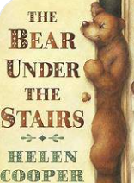
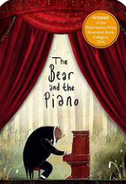
Autumn 1
The bear and the piano
The bear under the stairs

Geography
Where do I live?
The countries and capitals of the UK

RE
Surrey Syllabus
What is God like to Christians?

Computing
Information technology around us
Music
Get set for music - folksongs
PE
Fundamentals of PE
Gymnastics

Art
Artist: Yayoi Kusama
Different techniques to make polka dots

English
Retelling stories
Letters
Dialogue
Story telling
Performing with expression
Punctuation
Present and past tense
Handwriting
PSHE & RSE
Being me in my world
Belonging, fears and worries, rights and responsibilities, dreams and goals.

